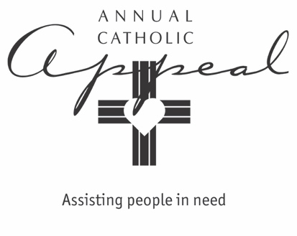

2024 TEXT AND ROBOCALL OUTREACH

For parishes that have regular communications with parishioners using text or robocall messaging: plan to include or modify these messages just before or just after your Appeal Weekend.

Hyperlinked text messages

- You can give people a path to dignity and help our parish to help others. Give online to the Annual Catholic Appeal. 25% comes back to our parish.

- Together as Catholics, we can help turn lives around. Give online to the Annual Catholic Appeal. 25% comes back to our parish.

- As we consider our Lenten sacrifices this year, let us remember all those who depend on our generosity through the Annual Catholic Appeal: those who need assistance and those who work tirelessly to serve them. Give online. It’s fast, easy and truly makes a difference.

Robocall message from pastor

Hello, this is Father ______________.

Every year at this time, we join all parishes in our diocese to assist others in need through the Annual Catholic Appeal. Your support in 2024 is very important to our parish. As we reflect on our blessings and consider our sacrificial acts during this Lenten Season, I ask all of us to do two things:

- Go to www.scd.org and watch the story in this year’s video. It is truly inspiring and reminds us that we make a profound difference in someone’s life with our financial support.

- Give what you can, either online or in the envelopes available here at the parish. 25% comes back to us for our (name of ministry).

The website again is www.scd.org.

Thank you for listening. You and your family, and all those who work tirelessly to serve others in need are in my prayers.

