Gospel Mass!!!

Join us to celebrate
Black History Month with a Gospel Mass at
Good Shepherd Catholic Church
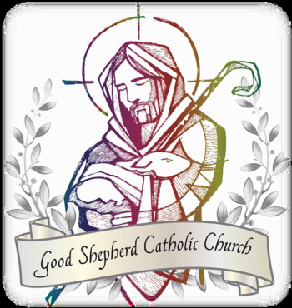

Address: 9539 Racquet Ct, Elk Grove, CA 95758
Date/Time: Saturday, Feb 19, 2022 @5pm

○ Music provided by The Voices of Praise & Youth Mass Choirs ○
○ Sponsored by the St. Josephine Bakhita Black Catholic Ministry ○
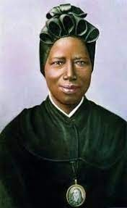

For more information visit www.gscceg.org or contact
Reggie Steward (rbs06@hotmail.com) or
Sonja Steward (sonja.steward@sbcgbobal.net).

