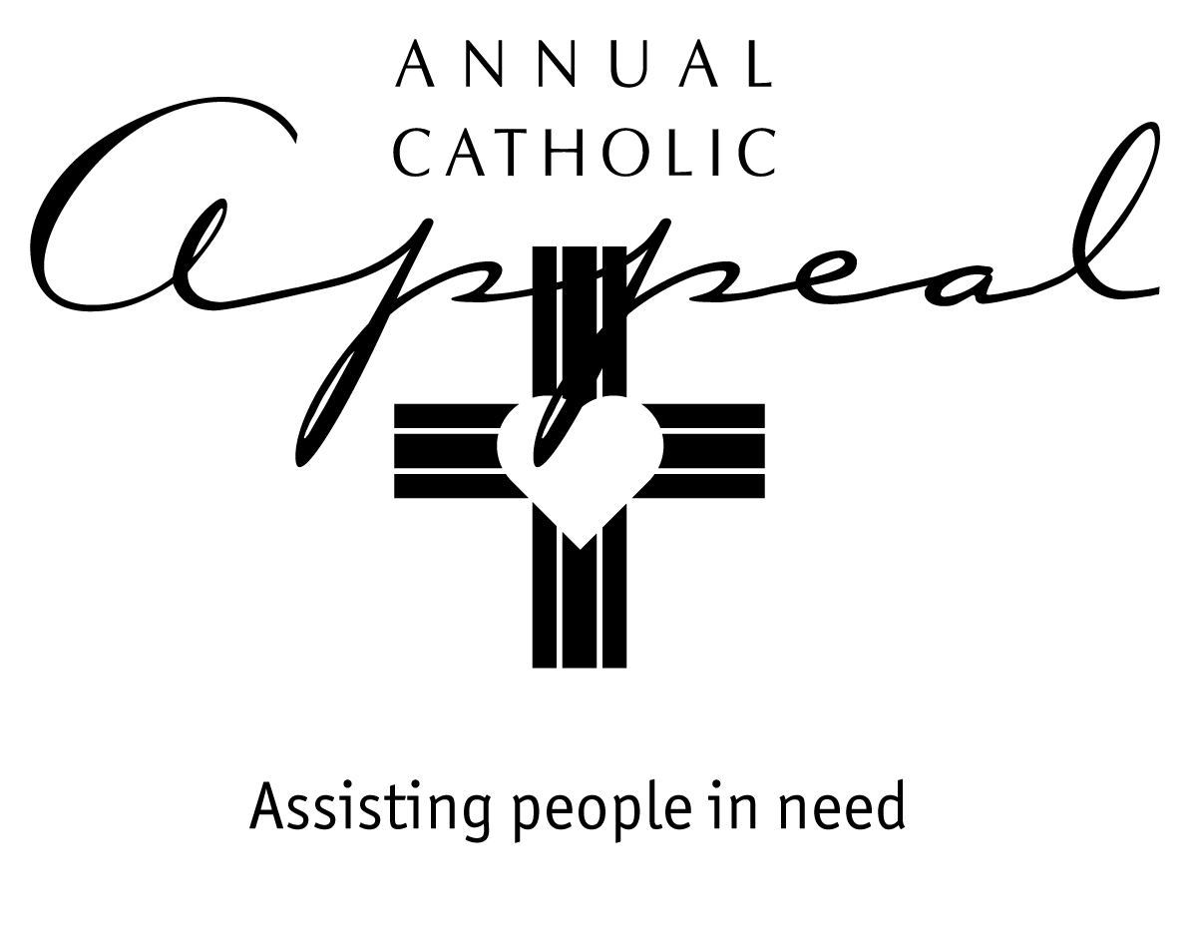

FEBRUARY 12/13 - 19/20
AWARENESS WEEKENDS

Bulletin and Mass Announcement

Bring God’s tender care to others through the Annual Catholic Appeal
25% comes back to our parish for our own outreach to those in need.

On the weekend of February 26 we will have the opportunity to come alongside those who are suffering through the Annual Catholic Appeal. Each of our gifts, no matter the amount, makes a difference in someone’s life. Catholic Charities can respond to the greatest needs in our communities. Seminarians receive support as they prepare to serve our local parishes. Catholic schools in economically-challenged neighborhoods can provide tuition assistance. And our ___________________________ ministry receives support for another year. Prayerfully consider what you can give this year.

Prayer of the Faithful

For our sisters and brothers in the Diocese of Sacramento…may the intercession of our Blessed Mother Mary bring to us the wisdom of her son Jesus as we consider our participation in the Annual Catholic Appeal, we pray…a

…Lord, hear our prayer.

(Please modify these announcements and prayers to fit your parish.
Consider adding how your parish will use the 25% share.)

FEBRUARY 26/27 – APPEAL WEEKEND

Bulletin and Mass Announcement

Today we join together through the Annual Catholic Appeal

We may not all be social workers, yet through the Annual Catholic Appeal, the whole Catholic community leans in to help our Catholic charities…and our own parish…to sustain programs and ministries that help lift our neighbors and friends out of the hardships of poverty.

The Annual Catholic Appeal is dedicated solely to the social mission of the Church here in Northern California. Last year, 314,000 people were helped by Appeal-funded charitable works. In our parish, _________________________________. Please be as generous as you can. Every gift makes a profound difference in someone’s life.

Prayer of the Faithful

For all who depend on our generosity through the Annual Catholic Appeal: those who need assistance and all those who work tirelessly in the charitable organizations and parish outreach ministries that serve them…

For our sisters and brothers we pray…

Lord, hear our prayer.

(Please modify these announcements and prayers to fit your parish)

MARCH 5/6 – MARCH 12/13
FOLLOW UP WEEKENDS

Bulletin and Mass Announcement

Thank you for helping our neighbors in need through
the Annual Catholic Appeal

Gifts that have already been made to the Appeal will make a difference in the lives of those who suffer physical, material and spiritual poverty. If you have not yet made a donation, it’s not too late! Donate online at www.scd.org/acagive. Envelopes are also available in the church or parish office. 25% is returned to our parish for our own ministry to people in our community. Your gift matters.

Prayer of the Faithful

For all who have given generously to the Annual Catholic Appeal…for those who are still prayerfully considering what they can give…and for all those who will benefit from our generosity…

For our sisters and brothers we pray…

Lord, hear our prayer.

(Please modify these announcements and prayers to fit your parish)

