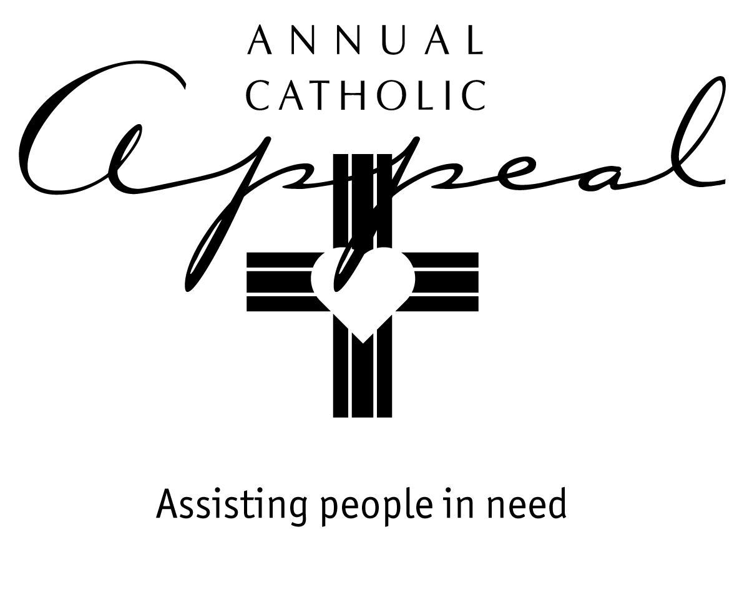

ANNUAL CATHOLIC APPEAL
GIFT PROCESSING PROCEDURES

The purpose of the gift processing procedures is to assist parish staff and The Catholic Foundation team in proactively reviewing and recording all contributions made to the Annual Catholic Appeal (ACA).

Please follow the following gift audit and recording steps so that we can:

- properly credit every donor
- accurately report the level of participation in your parish

Important Points to Remember when Auditing Gifts
- Checks should remain in the envelopes (DO NOT DEPOSIT CHECKS).
- ALL CASH needs to be removed from envelopes, write the amount of cash on the outside of each envelope.

- Return all contribution envelopes with donor information to The Catholic Foundation.

- Deposit ALL CASH and prepare a parish check to cover the envelopes and loose cash.

- Do not record gifts at the parish, The Catholic Foundation will process, record, and mail correspondence (thank you letter, pledge statements, tax letter) for each contribution.

Processing Instructions
Step 1: Have the following materials ready prior to processing contributions:
- Parish Transmittal Form
- Adding machine with tape
- Rubber bands
- Contribution envelopes
- Gift type labels for sorted envelopes

Step 2: Verify contents and sort the gift envelopes according to the following gift types:

Pledge and Recurring Gift Envelopes:  - w/ Checks  - w/ Credit cards  - w/ Direct debit  - w/ Cash payments  - w/o Payments | One-Time Gifts:  - w/ Checks  - w/ Credit cards  - w/ Direct debit  - Loose checks | Cash Gifts:  - Envelopes with donor information  - Anonymous envelopes
Step 3: Prepare a parish check to cover the CASH donations:
- The parish check should be made payable to the
Annual Catholic Appeal or ACA. On the check stub, please indicate the total amount of loose cash and anonymous gifts.

PLEASE DO NOT COMBINE ACA CONTRIBUTIONS WITH ANY OTHER COLLECTIONS.

Step 4: Prepare Parish Transmittal Form:
- Retain a copy of the Parish Transmittal Form for your records.

Step 5: Please send the completed package using the FedEx envelope provided OR a box that fits the collection. The Catholic Foundation will pay for shipping. Preprinted FedEx labels are provided for your use:

Annual Catholic Appeal
Diocese of Sacramento
2110 Broadway
Sacramento, CA 95818

Step 6: For any questions regarding processing gifts please call
916-733-0266 or Email: aca@scd.org

ANNUAL CATHOLIC APPEAL TRANSMITTAL FORM

Report No.: ______of______ Date: ____________________
Parish Name: ______________________________________________ City: _____________________
Contact Person: ____________________________________________ Telephone: ________________
PLEDGES and RECURRING GIFTS
#__________ Envelopes with checks
#__________ Envelopes with credit cards
#__________ Envelopes with direct debit payments
#__________ Envelopes with cash payments (Cash: $____________)
#__________ Envelopes without payments
ONE-TIME GIFTS
Checks, Credit Cards and Direct Debit Gifts
#__________ Envelopes with checks
#__________ Envelopes with credit cards
#__________ Envelopes with direct debit
#__________ Loose checks
Cash Gifts
#__________ Envelopes with donor information Total $________________
(The donor name and address are known.)
#__________ Anonymous envelopes Total $________________
(Donor information not known.)

Cash gifts without envelopes Total $________________

Parish Check Amount: $_________________
Important: Please deposit cash into your parish bank account and
make a check payable to “ACA” for the amount.

Mail the check and all donation envelopes to:
Annual Catholic Appeal, 2110 Broadway, Sacramento, CA 95818.

Report submitted by: ______________________ Audited by: ______________________
Parish Auditor Foundation Staff
Questions? Call 916-733-0266 or email aca@scd.org.

Labels for separated group bundles
(use each page folded in half to bundle each type of gift)

Pledge and Recurring Gift Envelopes
w/ checks

Labels for separated group bundles
(use each page folded in half to bundle each type of gift)

Pledge and Recurring Gift Envelopes
w/ credit cards

Labels for separated group bundles
(use each page folded in half to bundle each type of gift)

Pledge and Recurring Gift Envelopes
w/ direct debit payments

Labels for separated group bundles
(use each page folded in half to bundle each type of gift)

Pledge and Recurring Gift Envelopes
w/ cash payments

Labels for separated group bundles
(use each page folded in half to bundle each type of gift)

Pledge and Recurring Gift Envelopes
without payments

Labels for separated group bundles
(use each page folded in half to bundle each type of gift)

One-Time Gift Envelopes
w/ checks

Labels for separated group bundles
(use each page folded in half to bundle each type of gift)

One-Time Gift Envelopes
w/ credit cards

Labels for separated group bundles
(use each page folded in half to bundle each type of gift)

One-Time Gift Envelopes
w/ direct debit payments

Labels for separated group bundles
(use each page folded in half to bundle each type of gift)

Loose checks

Labels for separated group bundles
(use each page folded in half to bundle each type of gift)

Cash Gift Envelopes
w/ donor information

Labels for separated group bundles
(use each page folded in half to bundle each type of gift)

Cash Gift Envelopes
without donor information

