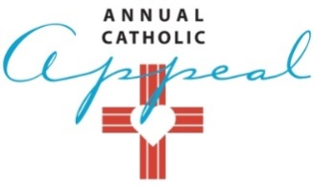
2020 PARISH SOCIAL MEDIA – February - June
Post | Image | Facebook – Instagram | Twitter
February 5 – 14 | File name: ACA20 Social_1 | Together as Catholics, people with developmental disabilities can enjoy a special time together. We also help our parish to reach out in love to our neighbors in need. Give generously on Appeal Weekend, February 22-23. Or donate online. 25% comes back to our parish. www.scd.org/donate | Together as Catholics, people with developmental disabilities can enjoy a special time together. Give generously on Appeal Weekend, February 22-23. Or donate online. 25% comes back to our parish. www.scd.org/donate
February 15 - 23 | 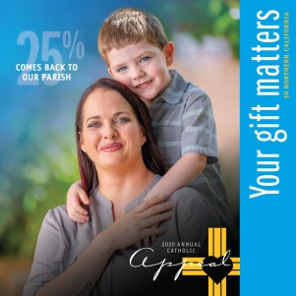  File name: ACA20 Social_2 | Together as Catholics, homeless, pregnant women find safety, learn parenting and how to be a family. We also help our parish to reach out in love to our neighbors in need. Prayerfully consider making a gift today. 25% comes back to our parish.  www.scd.org/donate . | Together as Catholics, homeless men and women find shelter and ways to cope with mental illness. Give generously this weekend at Mass. Or donate online. 25% comes back to our parish. www.scd.org/donate
February 24 – March 15 | 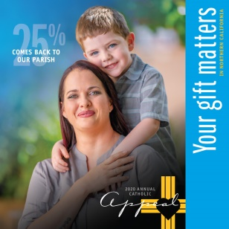  Continue File name: ACA20 Social_2 | Together as Catholics, homeless, pregnant women find safety, learn parenting and how to be a family. We also help our parish to reach out in love to our neighbors in need. Prayerfully consider making a gift today. 25% comes back to our parish.  www.scd.org/donate . | Together as Catholics, homeless, pregnant women find safety, learn parenting and how to be a family.  Prayerfully consider making a gift today. 25% comes back to our parish.  www.scd.org/donate
March 16 – April 13 | 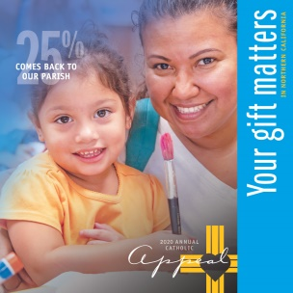  File name: ACA20 Social_3 | Together as Catholics, families are supported with parent education, English classes and a place to go for emotional support. We also help our parish to reach out in love to our neighbors in need. Prayerfully consider making a gift today. 25% comes back to our parish.  www.scd.org/donate | Together as Catholics, disaster victims, like those who lost everything in Northern California’s devastating wildfires, find relief. Prayerfully consider making a gift today. 25% comes back to our parish.  www.scd.org/donate
April 14 – May 14 | 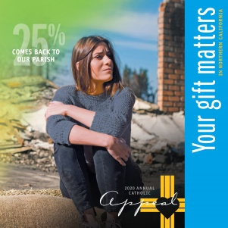  File name: ACA20 Social_4 | Together as Catholics, disaster victims, like those who lost everything in Northern California’s devastating wildfires, find relief. We also help our parish to reach out in love to our neighbors in need. Prayerfully consider making a gift today. 25% comes back to our parish.  www.scd.org/donate | Together as Catholics, disaster victims, like those who lost everything in last year’s Carr and Camp fires, find relief. Give generously this weekend at Mass. Or donate online. 25% comes back to our parish.  www.scd.org/donate
May 15 – June 15 | File name: ACA20 Social_5 | Together as Catholics, adults gain life-improving skills. We also help our parish to reach out in love to our neighbors in need. If you haven’t already made a gift to the Annual Catholic Appeal, prayerfully consider making a gift today. 25% comes back to our parish.  www.scd.org/donate | Together as Catholics, adults gain life-improving skills. Prayerfully consider making a gift today. 25% comes back to our parish.  www.scd.org/donate
June 15 – July 15 | 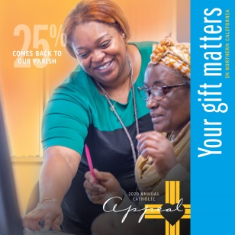  File name: ACA20 Social_6 | Together as Catholics, adults gain life-improving skills. We also help our parish to reach out in love to our neighbors in need. If you haven’t already made a gift to the Annual Catholic Appeal, prayerfully consider making a gift today.  25% comes back to our parish. www.scd.org/donate | Together as Catholics, adults gain life-improving skills. Prayerfully consider making a gift today. 25% comes back to our parish. www.scd.org/donate
July 15 + | File name: ACA20 Social_7 | Together as Catholics, single moms living on the margins find food for their children and a path to self-confidence. We also help our parish to reach out in love to our neighbors in need. If you haven’t already made a gift to the Annual Catholic Appeal, prayerfully consider making a gift today. 25% comes back to our parish.  www.scd.org/donate | Together as Catholics, single moms living on the margins find food for their children and a path to self-confidence. Prayerfully consider making a gift today.25% comes back to our parish.  www.scd.org/donate

