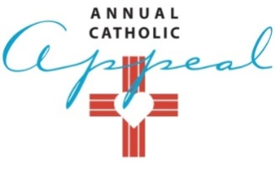

2018 PARISH SOCIAL MEDIA – March 8 – May 27
Post | Image | Parish Facebook Parish Instagram |  |  |  | Twitter
Post  Thursday  March 8 | 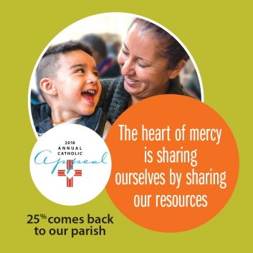  File name: ACA Social_1 | This Easter Season, prayerfully consider a gift to the Annual Catholic Appeal. Thank you to those who have already given. Your gift will make a difference in someone’s life – and to our parish. Please share this opportunity to be The Heart of Mercy in Northern California. | This Easter Season, prayerfully consider a gift to the Annual Catholic Appeal. Thank you to those who have already given. Please share this opportunity to be The Heart of Mercy in Northern California. | Prayerfully consider a gift to the Annual Catholic Appeal and share this opportunity to be The Heart of Mercy in Northern California.
Post  Thursday  April 5 | 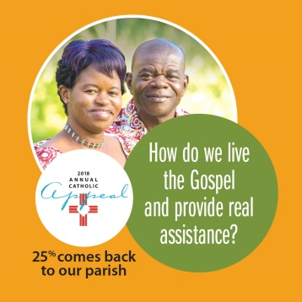  File name: ACA Social_2 | Catholic social service programs and parish ministries depend on all of us. Support charitable works and share this opportunity to be The Heart of Mercy in Northern California. 25% comes back to our parish. | Support the good works of our Church and share this opportunity to be The Heart of Mercy in Northern California.  25% comes back to our parish. | Prayerfully consider a gift to the Annual Catholic Appeal and share this opportunity to be The Heart of Mercy in Northern California.
Post  Thursday  April 26 | 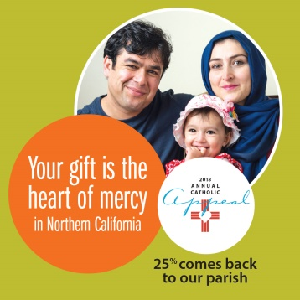  File name: ACA Social_3 | Your gift will make a difference in someone’s life – and to our parish. If you have not yet made a donation prayerfully consider a gift and share this opportunity to be The Heart of Mercy in Northern California. 25% comes back to our parish. | If you have not yet made a donation to the Annual Catholic Appeal, prayerfully consider a gift and share this opportunity to be The Heart of Mercy in Northern California. | Prayerfully consider a gift to the Annual Catholic Appeal and share this opportunity to be The Heart of Mercy in Northern California.
Post  Thursday  May 17  NEW ASSETS WILL BE PROVIDED FOR  JUNE-AUG | 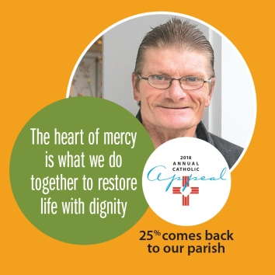  File name: ACA Social_4 | Your gift to the Annual Catholic Appeal makes it possible for more people to be part of society once again. Prayerfully consider a gift and share this opportunity to be The Heart of Mercy in Northern California. 25% comes back to our parish. | If you have not yet made a donation to the Annual Catholic Appeal, prayerfully consider a gift and share this opportunity to be The Heart of Mercy in Northern California. | Prayerfully consider a gift to the Annual Catholic Appeal and share this opportunity to be The Heart of Mercy in Northern California.

