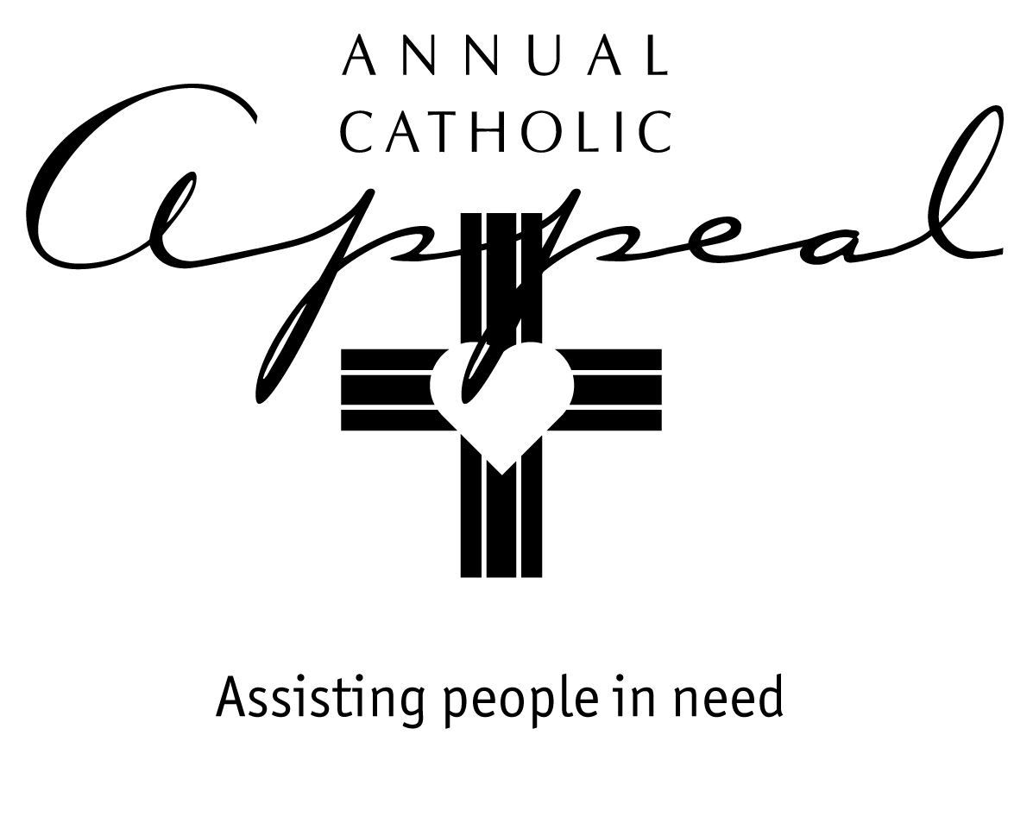

JANUARY 27/28 - FEBRUARY 3/4
AWARENESS WEEKENDS

Bulletin and Mass Announcement

In two weeks (next weekend), on Feb 10-11, we will once again be given the opportunity to be Christ to others. How do we help a family that has suffered great loss? How do we help the homeless man or woman who is looking for a way out of poverty? How do we provide emotional support where it is needed most? As Catholics in the Diocese of Sacramento, we have a way to help those truly in need. By making a generous donation to the Annual Catholic Appeal, you can live the Gospel message to help our brothers and sisters. Last year _____ of our parishioners contributed $_______. Our parish received 25% to serve our local ministry to others. The charitable works of the Church, whether in Catholic social service programs or parish-based outreach ministries, depend on all of us. Each of our gifts, no matter the amount, really does make a difference in someone’s life. Please prayerfully consider what you can give. Our gift is the Heart of Mercy in Northern California.

Prayer of the Faithful

For the local Church…the People of God in the Diocese of Sacramento…as we consider all that God has so generously given us, that He will open our hearts as we prayerfully consider our participation in the upcoming Annual Catholic Appeal and for those who need assistance…

For our sisters and brothers we pray…Lord, hear our prayer.

(Please modify these announcements and prayers to fit your parish. Revise line 9 in the Announcement
to feature how your parish used the 25% share.)

FEBRUARY 10/11 – APPEAL WEEKEND

Bulletin and Mass Announcement

The 2018 Annual Catholic Appeal is our annual tradition that connects us to thousands of people who need our help every day. Our generous gifts to the Appeal help children find safety and hope, families break through desperate situations, marginalized individuals find the strength to rebuild lives of dignity, students in economically challenged communities remain in Catholic school, and seminarians prepare for priestly service in our parishes. We may not be social workers, yet we are at the heart of mercy when we put our resources in the hands of social service programs and parish ministries that help lift people out of poverty. Please be as generous as you can. Every gift makes a difference.

Prayer of the Faithful

For all who depend on our generosity in the Annual Catholic Appeal: those who need assistance and all those who work tirelessly in the charitable organizations and parish outreach ministries that serve them…

For our sisters and brothers we pray…

Lord, hear our prayer.

(Please modify these announcements and prayers to fit your parish)

FEBRUARY 17/18 – 24/25
FOLLOW UP WEEKENDS

Bulletin and Mass Announcement

Thank you to those who have already made a one-time or an ongoing donation to the 2018 Annual Catholic Appeal. Your gift will make a difference in someone’s life. If you have not yet made a donation, it’s not too late! Envelopes are still available in the church or in the parish office. Don’t forget… 25% of what you give is returned to our parish to assist people in our community who need help.

Prayer of the Faithful

For all who have given generously to the Annual Catholic Appeal… for those who are still prayerfully considering what they can give… and for all those praying for help from God who will benefit from our generosity…

For our sisters and brothers we pray…

Lord, hear our prayer.

(Please modify these announcements and prayers to fit your parish)

REPORT TO PARISHIONERS:
OVERALL PARISH COLLECTIONS RESULT

MAY - JUNE
One week after receipt of Progress Report from Diocese.

Bulletin and Mass Announcement

Thank you to those who have already made a gift to the 2018 Annual Catholic Appeal. Your gift will make a difference in someone’s life. As of (date), _______ parishioners have participated this year at our parish, totaling $___________ in gifts and pledges. If you have not yet made a donation, it’s not too late! Prayerfully consider a gift. No contribution, no act of charity is ever too small or insignificant. Envelopes are still available in the church or the parish office. Don’t forget… 25% of what you give is returned to our parish. This year, Appeal funds will be used to _________________.

(Please modify these announcements to fit your parish)

